



**USER guide**

*Logistics Ordering Tool*

December 2015

**Revision Sheet**

|  |  |  |
| --- | --- | --- |
| **Release No.** | **Date** | **Revision Description** |
| Rev. 0 | Nov/16/2015 | User’s Manual Created |
| Rev. 1 | Nov/24/2015 | Added conversion program information |
|  |  |  |
|  |  |  |
|  |  |  |

**USER'S MANUAL**

**TABLE OF CONTENTS**

Page #

1.0 GENERAL Overview 1-1

1.1 System Overview 1-1

1.2 Acronyms and Abbreviations 1-1

2.0 SYSTEM SUMMARY 2-1

2.1 System Configuration 2-1

2.2 User Access Levels 2-1

2.3 System Architectures 2-1

2.3.1 Background worker 2-1

2.3.2 Submitting Order 2-2

2.3.3 Updating Shipment Status 2-2

2.3.4 Update the order 2-3

2.3.5 Review Order 2-3

2.3.6 AMS 2-4

3.0 FEATURES 3-1

3.1 Admin user 3-1

3.1.1 Default Page 3-1

3.1.2 Setting up Province 3-2

3.1.3 Setting up Unit 3-2

3.1.4 Setting up Commodity Categories 3-2

3.1.5 Setting up Category for Lab Testing 3-3

3.1.6 Setting up Regimen Categories 3-3

3.1.7 Setting up Lab Test 3-4

3.1.8 Setting up Regimen 3-4

3.1.9 Setting up SMS Message Templates 3-5

3.1.10 Setting up Commodities 3-5

3.1.11 Setting up Sites 3-6

3.1.12 Setting up Users 3-6

3.1.12 SMS Log 3-8

3.2 Site user 3-12

3.2.1 Download Template 3-12

3.2.2 Create a New Order 3-12

3.2.3 Order status 3-13

3.2.4 Filter order 3-14

3.2.5 Update Shipment Status with SMS 3-14

3.3 Data Entry User 3-15

3.3.1 Dashboard 3-15

3.3.2 Order Listing 3-15

3.3.3 Edit Order 3-16

3.3.4 Delete Order 3-17

3.3.5 Reject Order 3-17

3.3.6 Cancel rejection 3-18

3.3.7 Order detail 3-18

3.3.8 Download original order from site 3-19

3.3.9 Export List 3-19

3.3.10 Export Requisition and Order 3-20

3.3.11 Filter orders 3-21

3.4 AMS User 3-21

3.4.1 Dashboard 3-21

3.4.2 Order Listing 3-22

3.4.3 Download submitted Requisition and order form 3-22

3.4.4 Export List 3-23

3.4.5 Export Requisition and Order 3-23

3.4.6 Order Filter 3-24

3.4.7 Order Detail 3-24

3.4.8 Order pending for dispatch 3-24

3.4.9 Filter Result 3-25

3.4.10 Create Shipment 3-25

3.4.11 Shipment Status 3-27

3.4.12 Shipment Detail 3-27

3.4.13 Site SMS Messages 3-28

3.4.14 Update shipment status 3-28

3.4.15 Package 3-29

**1.0 GENERAL OVERVIEW**

# GENERAL Overview

## 1.1 System Overview

Logistics Ordering Tool (LOT) is a web application that utilizes an intuitive user interfaces that allow PNG HIV health worker play roles (Site, Data Entry, Data Entry and Reviewer, Reviewer, AMS and Admin) to collaborate in a predefined workflow. This application provides a graphical user interface that allows a user to input all information and store it electronically to exterminate the need for using paper records, automatic remind to site user to send requisition order and update the status of shipment.

This application uses a client/server model. Any browser that is connected to Internet can be used as a client. The server hosts in amazon cloud instance at <http://52.76.199.148>.

## 1.2 Acronyms and Abbreviations

LOT – LOGISTICS ORDERING TOOL collaboration tool for tracking HIV supply across PNG.

MySQL – This is an open source SQL database server used to store all information for each student.

APACHE – This is an open source web server used to accept http request from browsers.

**2.0 SYSTEM SUMMARY**

# SYSTEM SUMMARY

## 2.1 System Configuration

Each user uses its own computer with any modern browser (Firefox, Google Chrome). Browser connects to http://52.76.199.148 server (Ubuntu Server). Clients computer require Internet connection to access the server. No extra configuration requires using this tool.

## 2.2 User Access Levels

There are 5 different roles of users described below

**Admin users** are those who are responsible for setting up the initial data setting up users, commodities, sites, provinces, SMS template and so on.

**Site users** are those who are located in a specific HIV site. They are responsible for submitting requisition order. They receive the shipment from AMS users; they also can send SMS to PNG LOT phone number updating the shipment status.

**Data Entry users** are those who responsible for creating SURV form for completing requisition orders of site. Edit and save order requisition submitted from sites to be able to send to be reviewed to reviewer users.

**Reviewer users** are those who responsible for reviewing order requisition from **Data Entry** user. Reviewer can reject and accept each order item. If order requisition is accepted, then the system will make it available for AMS, otherwise it will available for Data Entry user to correct it.

**AMS users** are those who responsible for order shipment. After Reviewer users approved the order, the order will appear to AMS. AMS can choose items from the list and ship.

## 2.3 System Architectures

LOT system has 6 following group of users that can interact with the system

1. Admin
2. Site User
3. Data Entry User
4. Data Entry and Reviewer User
5. Reviewer User
6. AMS

And a background worker running a scheduled job as a [CRON](https://www.google.com/url?sa=t&rct=j&q=&esrc=s&source=web&cd=5&cad=rja&uact=8&ved=0ahUKEwiT5JCmkrfJAhWEJZQKHYgvC6YQFggzMAQ&url=https%3A%2F%2Fen.wikipedia.org%2Fwiki%2FCron&usg=AFQjCNEmgLdsZSTPiYa-rMMx7UzAP6AdJQ&sig2=1qFoN5fIv_sqtR3QuoxNUw) to send SMS alert to Site User.

### 2.3.1 Background worker

System will perform a scheduled job to check the deadline of order from site. If site users meet the deadline to order then the system will send SMS alert to his/her mobile.

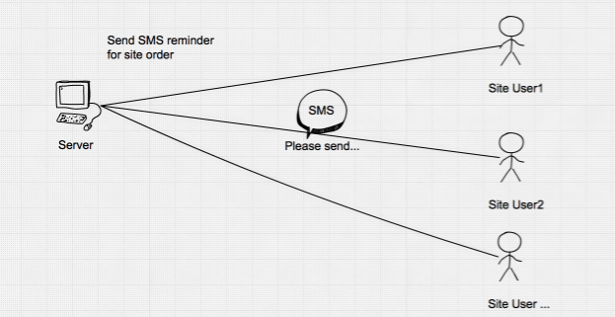

Fig. CRON System checks and remind site user about requisition report

### 2.3.2 Submitting Order

Site Users are expected to submit order to the system by downloading the excel template, fill in the data and submit it to the system.

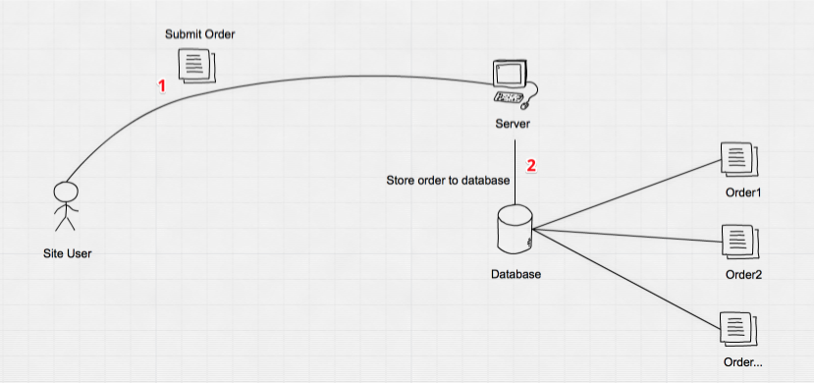

Fig. Site User submits and order to system.

### 2.3.3 Updating Shipment Status

Site Users update the shipment status by sending SMS to the system phone number(Local gateway).

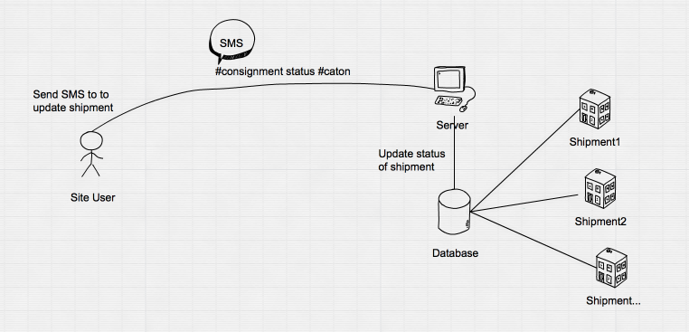

Fig. Site User sends SMS to update the status of shipment.

### 2.3.4 Update the order

Data Entry User update the order and the system changes the order status to “To be reviewed”, thus this order is available for Reviewer User to review it.

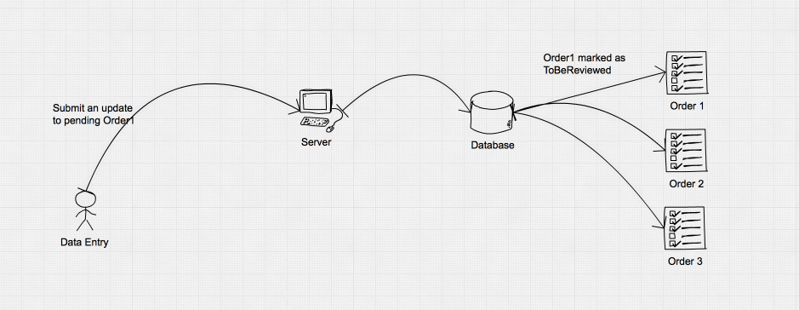

Fig. Data Entry update

### 

### 2.3.5 Review Order

Reviewer can **Accept** or **Reject** the order modified by Data Entry user.

If the order is rejected then the system will change the order status to “To be revised” and Data Entry User can quickly edit the order again.

If the order is accepted then the order status will change to “Approved” and the AMS User will be able to ship the package.

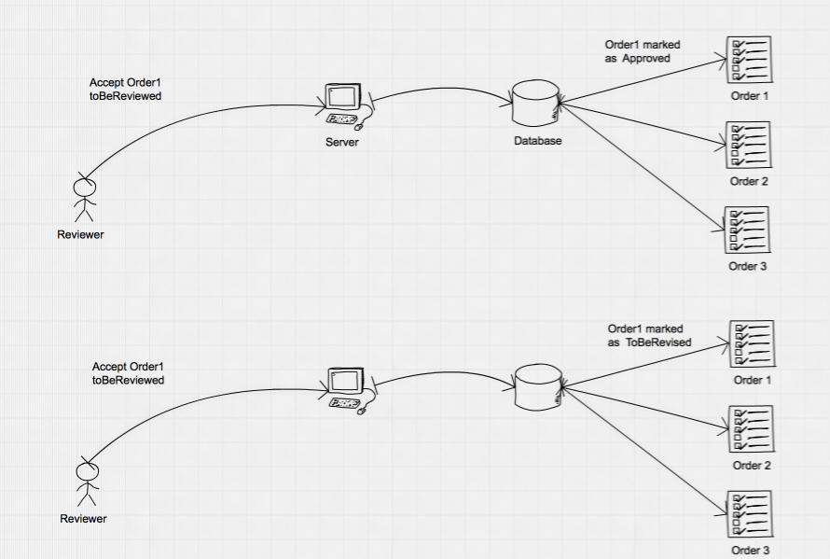

### 2.3.6 AMS

After an order is marked as Approved, orders will be shown in AMS shipment list. AMS choose one or more items from the same order to ship. If shipment can be done then a SMS alert will send to original Site User and the items will be remove from the shipment list.

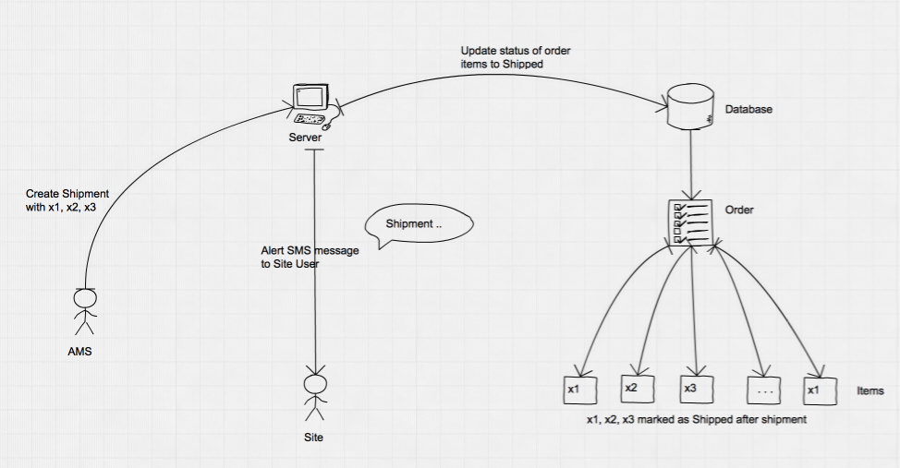

**3.0 FEATURE**

# FEATURES

Before making any action, users need login first.

In your browser visit: http://52.76.199.148. You will be redirected to log in page if you have not logged in yet as below:

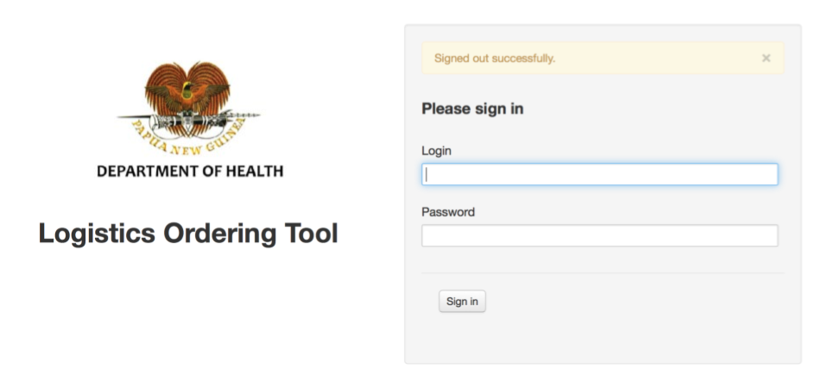

## 3.1 Admin user

### 3.1.1 Default Page

For Admin User the default page is the SMS Logs

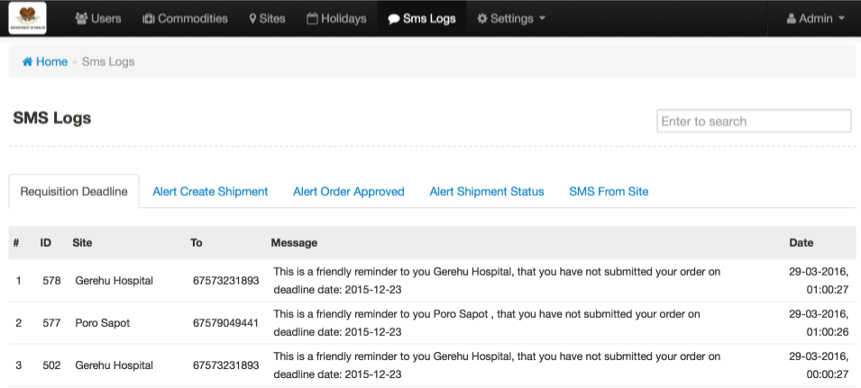

### 3.1.2 Setting up Province

Go **Settings -> Provinces** LOT will show the provinces listing

## Macintosh HD:Users:ilab:Project:png user guide:pages:province.png

You can create a new province, edit or delete an existing one. When you edit a province then all other tables that are related to the province will get a new update.

If you try to **delete** a province that is being **associated** with other tables, for instance, **Sites list** then the system will complain and you will be rejected from being able to delete the province. If you really want to remove the province on purpose then you must disconnect the association by removing or editing to related value (site) to break the association. **This concept applies to all tables in the LOT**.

### 3.1.3 Setting up Unit

Go to Settings -> Units then LOT will show the units listing

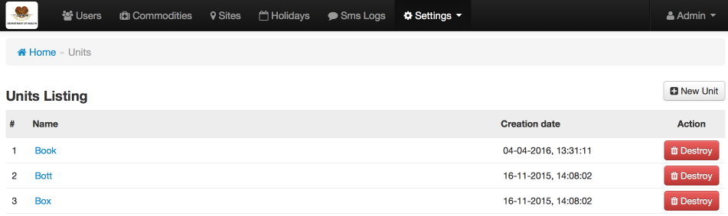

### 3.1.4 Setting up Commodity Categories

Go to Settings -> Commodity Categories then LOT will show

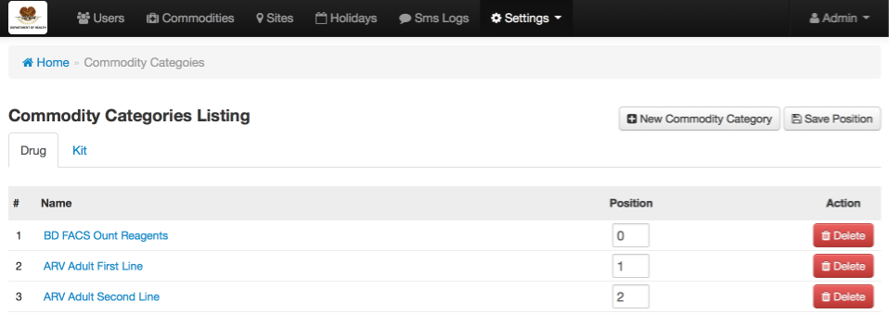

There are 2 types of commodity categories – Drug and Kit. They are represented as a tab so to switch between Drug and Kit you simply click on the tab.

### 3.1.5 Setting up Category for Lab Testing

Go to Settings -> Lab Test Categories then LOT will show the list of lab testing categories

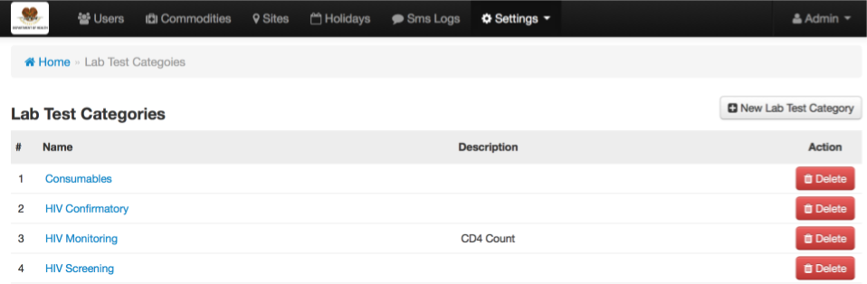

### 3.1.6 Setting up Regimen Categories

Go to Settings -> Regimen Categories then LOT will show listing of Regimen Categories

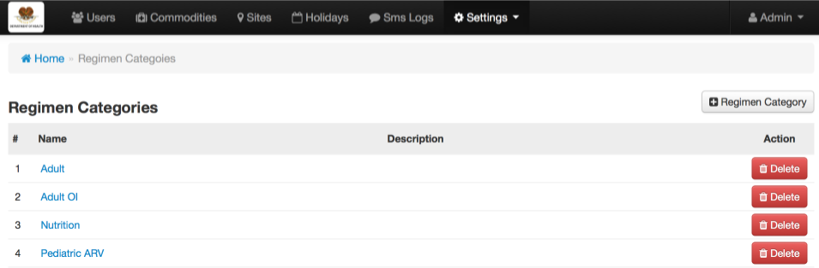

### 3.1.7 Setting up Lab Test

Go Settings -> Lab Test then LOT will show the listing of Lab Testing

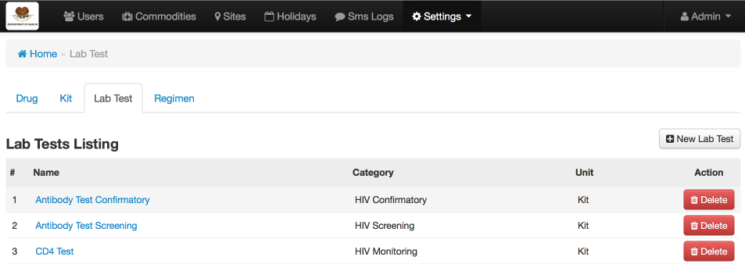

### 3.1.8 Setting up Regimen

Go to Settings -> Regimen then LOT will show the listing of Regimen

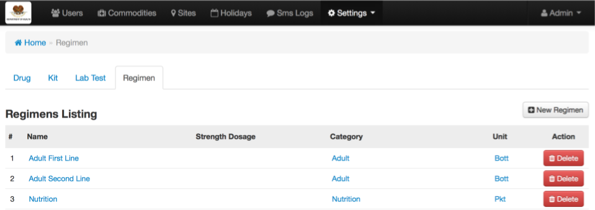

### 3.1.9 Setting up SMS Message Templates

Go to Settings -> SMS Message Template then LOT show the entire templates configuration to all aspect of SMS message in LOT system.

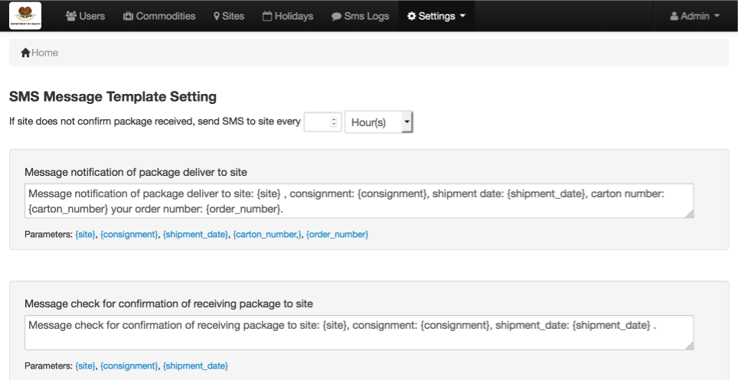

### 3.1.10 Setting up Commodities

Go to Commodities on the top menu bar then LOT will show the listing of commodities

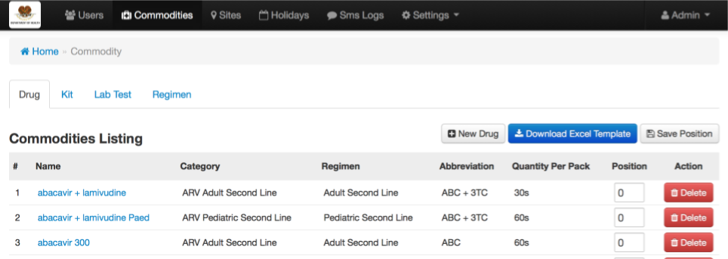

Actually there are only 2 types of commodities – Drug and Kit. They are corresponding to Drug and Kit commodity categories. These 2 types of commodities are represented as a tab. You can switch between commodities by click on the tab. Lab Test and Regimen is represented as tab here as quick access because commodities are mostly related to regimen and lab testing.

Beside create/edit/delete commodities admin user can rearrange position of the commodities to manage the order of appearance by changing the text box position and then click on the ‘**Save Position**’ button.

### 3.1.11 Setting up Sites

Go to Sites on the top menu bar then LOT will show the listing of sites

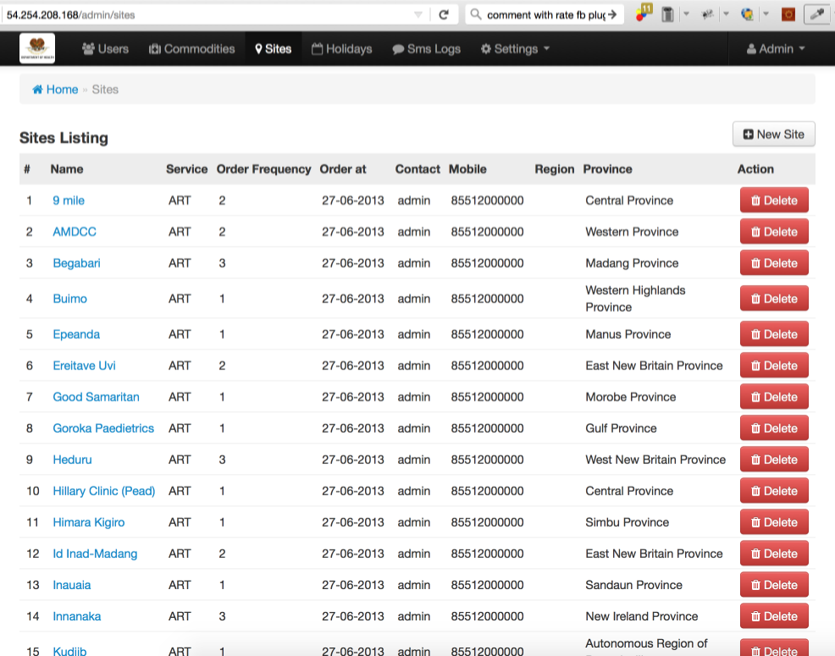

### 3.1.12 Setting up Users

Go to Users then LOT will show the listing of users

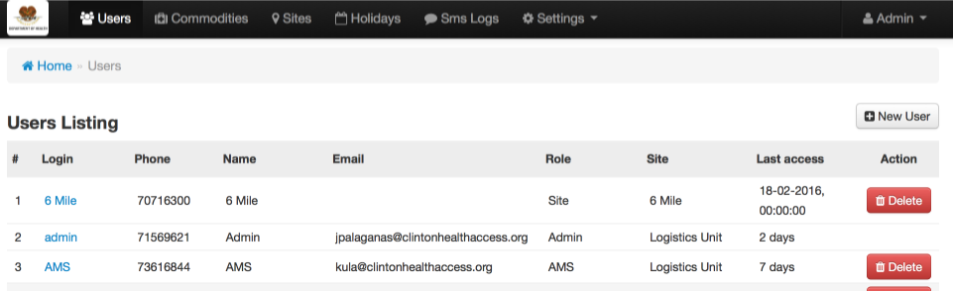

#### **Add new User**

Go to Users -> New User

### Macintosh HD:Users:ilab:Project:png user guide:pages:user new.png

If you choose Role value “Site” then you must choose a site for the user.

#### **Edit user**

To edit user click on Users menu to show the User list.

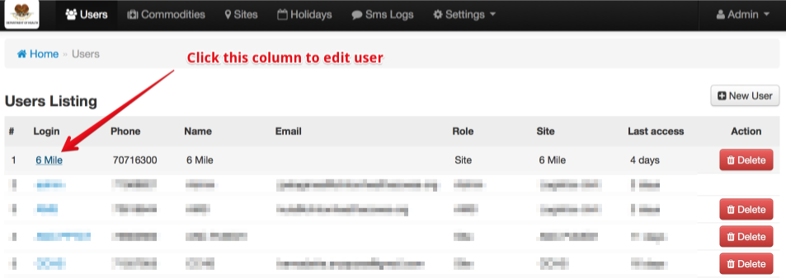

After click this link it will bring you to edit user page

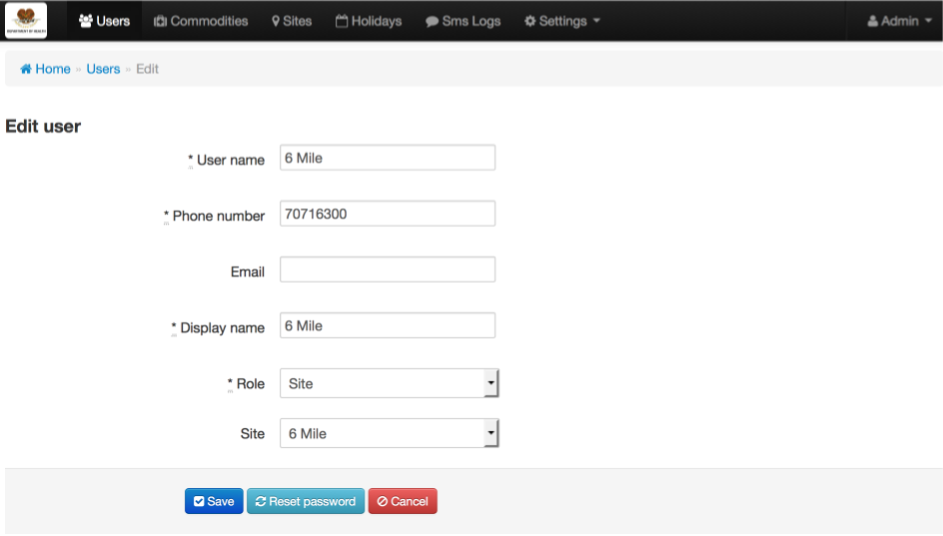

Modify the data and click save.

#### **Reset User password**

In the edit user page, Click **Reset password** button and confirm the action to proceed.

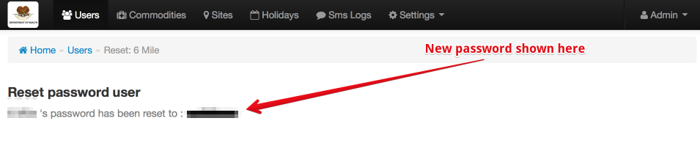

### 3.1.12 SMS Log

Provide an easy to monitor all SMS activities within the LOT. There are 5 types of log within the tool.

* **Requisition Deadline**: is a system generated SMS to send to site that meet the requisition deadline (configurable). The SMS contain the site name, the site user phone number, the text that generates by the system to remind the site user and the date time that the SMS was sent out.

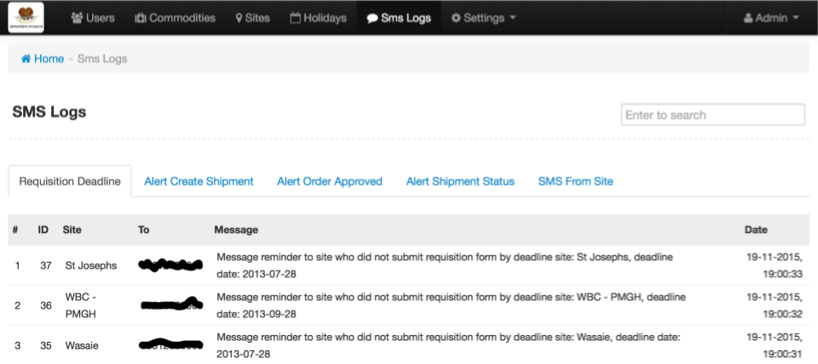

* **Alert of Shipment creation**: is a system generated SMS. After an AMS user creates a shipment in the system the tool will automatically generate this SMS and send it out to the site user. The log contain the Site name, the site user’s phone number, the SMS message to notify the site user and the date time that the tool sent the sms.

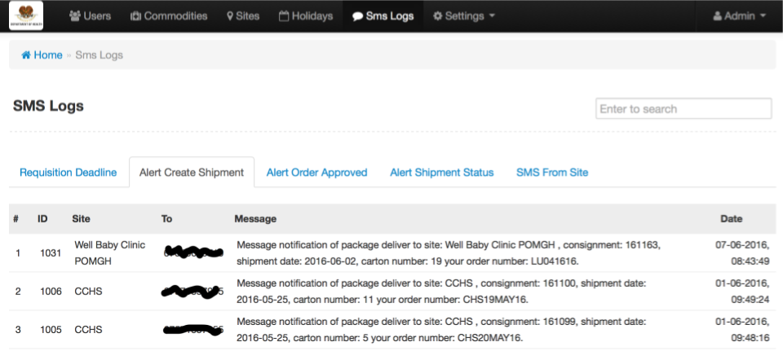

* **Alert order approved**: is a system generated SMS. When an order is approved, the tool will generate an SMS and send it out to inform site user that the order has been approved. The log contains the site name, the site user’s phone number, the notification message and the date time that the tool send this message to user’s phone number

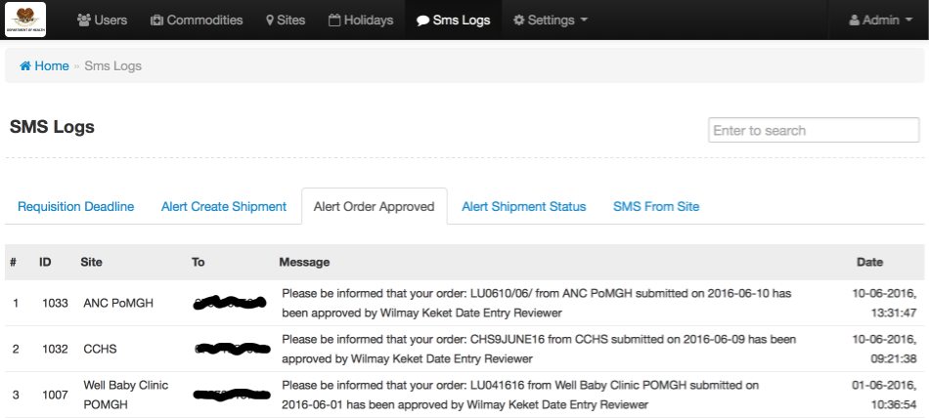

* **Alert Shipment**: is a system generated SMS that is used to send to site user’s phone number to confirm status of receiving package delivered to site. After seeing this the site user should be aware of their package delivery status. The log contains site name, the site user’s number, the information of shipment (consignment number, date, number of boxes, …).

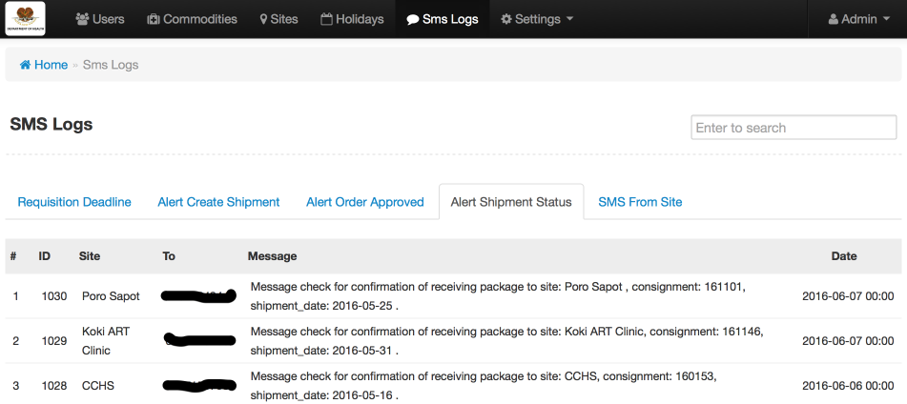

* **SMS from site user**: is a SMS that the site user sends to the system to feedback the alert shipment status. The tool will analyze the SMS from user to check if the syntax is valid and response backs to site user accordingly. The log contains the phone number of the sender (from), the SMS that was sent to system (message), and analyzed fields calculated by system (consignment number, shipment status, number of carton) and an error field to mark whether the SMS is valid or not.

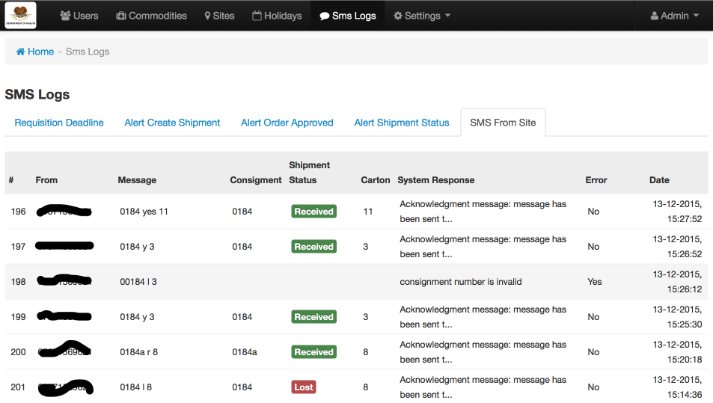

* **SMS Log Filter**: allow admin to search for system generated SMS. This help to troubleshoot, for example, the SMS actually sends to user at specific time. To filter you just need to write any particular part of the message in the filter box and press enter as shown below.

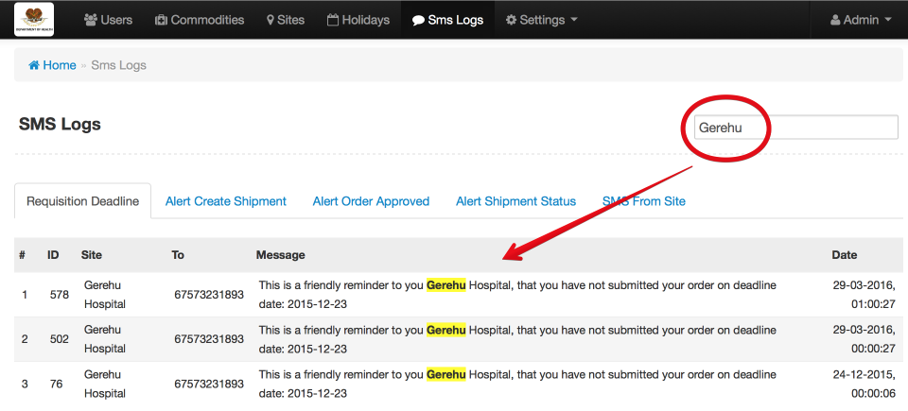

## 3.2 Site user

### 3.2.1 Download Template

Click on the blue button “Download Template“ and then save the file in you computer.

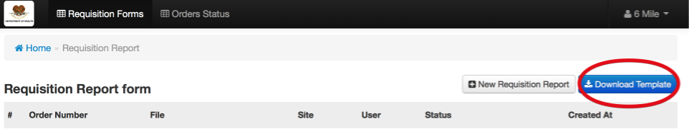

Open the downloaded file with MS Excel. Fill in the values

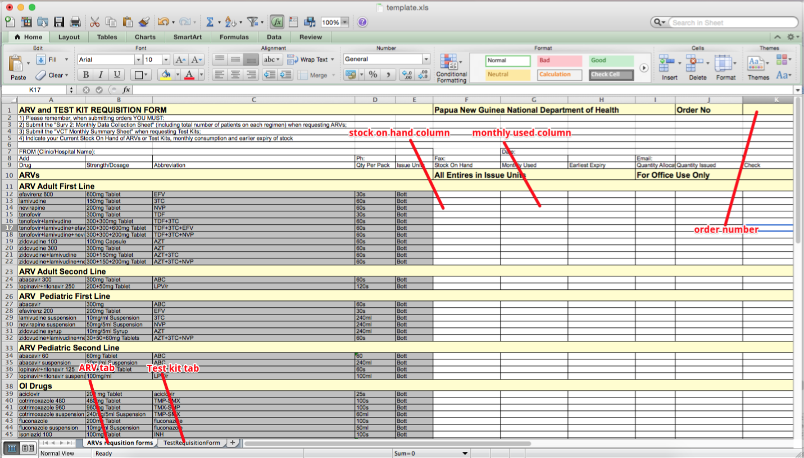

### 3.2.2 Create a New Order

Click on “New Requisition Report”

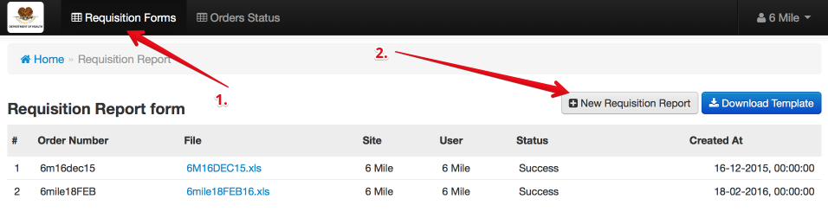

Then, should the file to update can click save

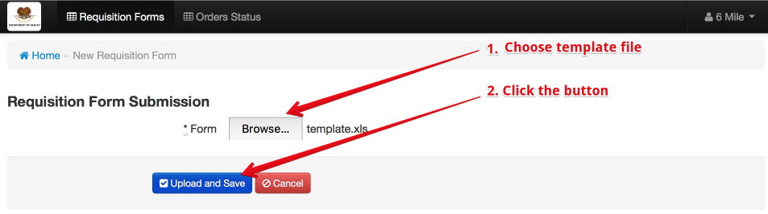

Then the order will appear in the order list and Data Entry/Data Entry and Reviewer will be able to see it.

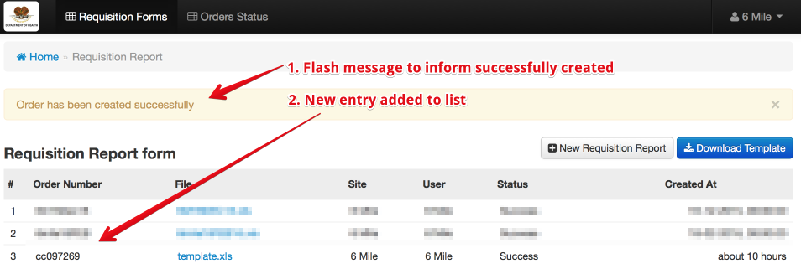

### 3.2.3 Order status

Site user can check the status of his/her orders by clicking “Order Status” on the top menu.

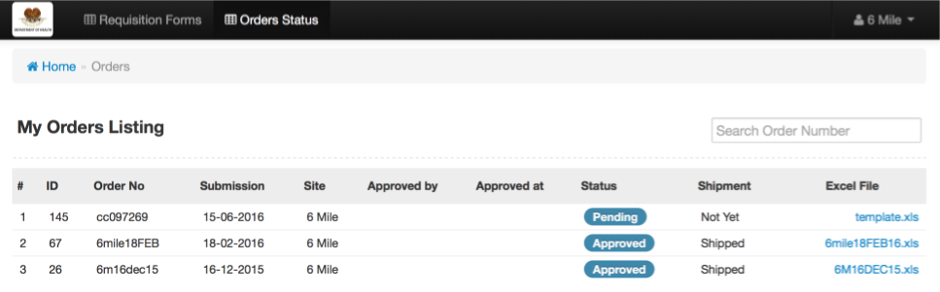

As an example there are 2 approved orders and one pending order. In case you have large amount of order you can filter orders by order number entering in the Search Order Number and press enter.

### 3.2.4 Filter order

###### In case you have large amount of order you can filter orders by order number entering in the Search Order Number and press enter.

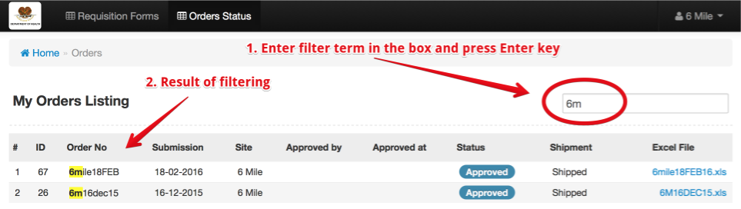

### 3.2.5 Update Shipment Status with SMS

In order to update the shipment status, the site users need the following information from the shipment:

* Consignment number
* Carton number
* A phone with mobile number registered in the Site of the package.

The SMS need to be sent to the system phone number (this number will provided by admin)

Below is the syntax to update the shipment status

*[consignment_number] [status] [carton_number]*

Example: 28494 r 6

Where:

* Consignment is: 28494
* Status is: r
* Carton Number is: 6

Valid values for status are:

* Confirmed (r, y, yes)
* Lost (l, n, no, not, lost)
* Partially received (p, partial)

## 3.3 Data Entry User

### 3.3.1 Dashboard

Data Entry User Dashboard is a quick show of number of order corresponding to its status.

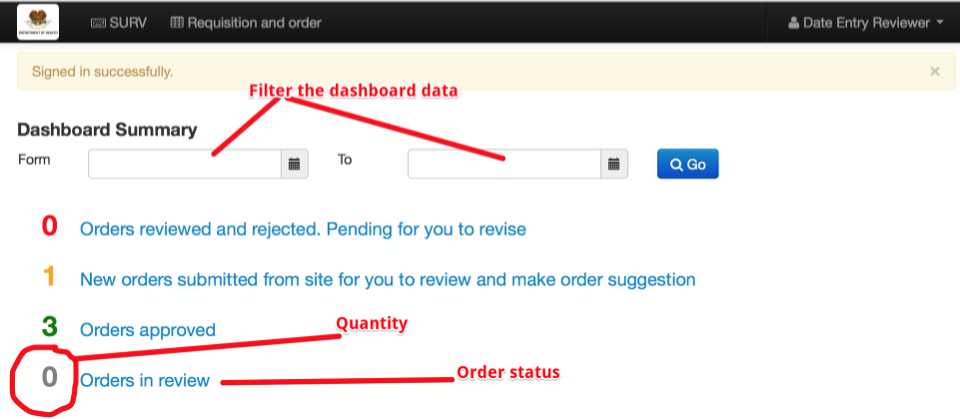

### 3.3.2 Order Listing

You can access to Order Listing with 2 ways:

* On dashboard page, click on an item, it will open the order listing with that **status**.
* On the top menu, click on the “Requisition and order“.

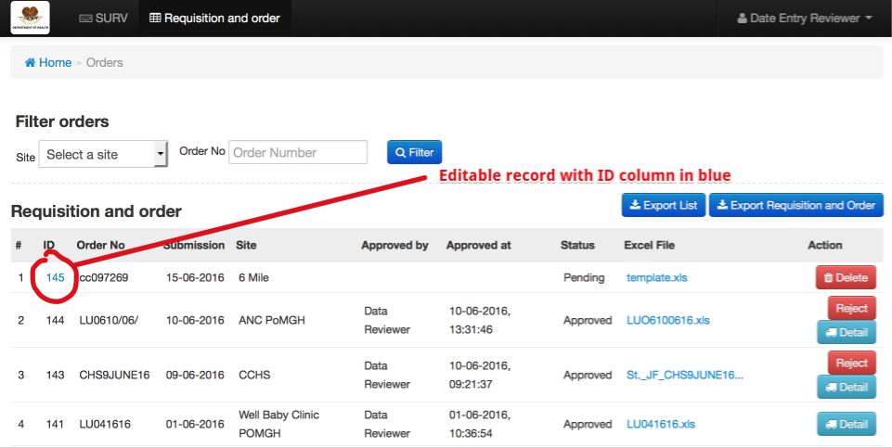

### 3.3.3 Edit Order

Data Entry User can edit or delete only orders with status pending. If the order is pending then in the column ID the number will appear as a blue link that can be click to edit the order.

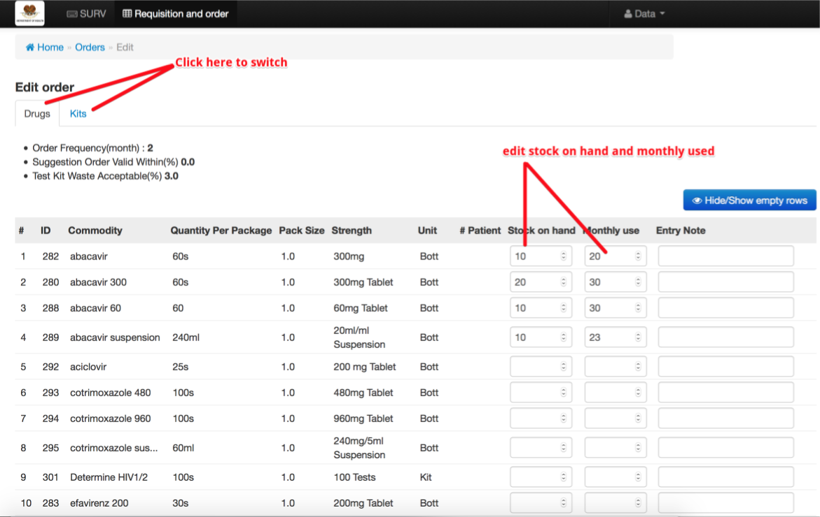

After finishing your modification, then scroll down and click the Save button.

The system will save the order and turn its status to “To Be Review” and will be available for Reviewer and DataEntryAndReviewer User to Review and you are no longer able to modify the order.

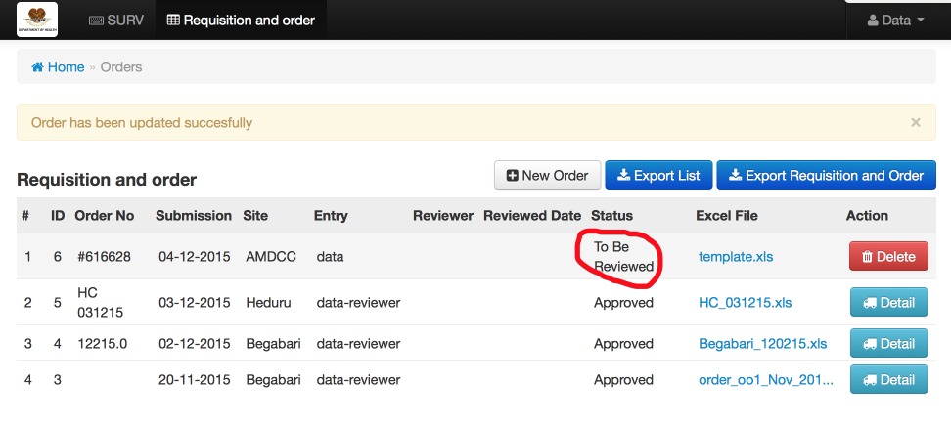

### 3.3.4 Delete Order

Clicking on the Delete button of Requisition and order listing

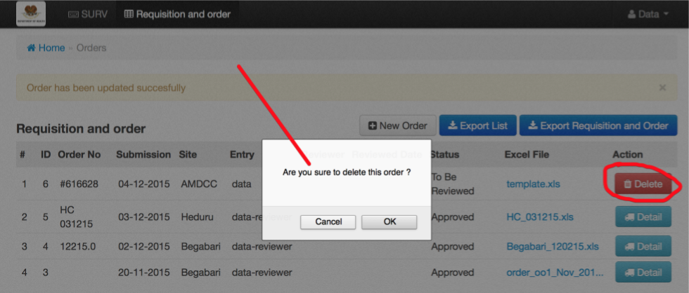

### 3.3.5 Reject Order

Once an order is approved it will be shown in AMS page. If you approve the order by mistake you can reject the order so will not appear in AMS.

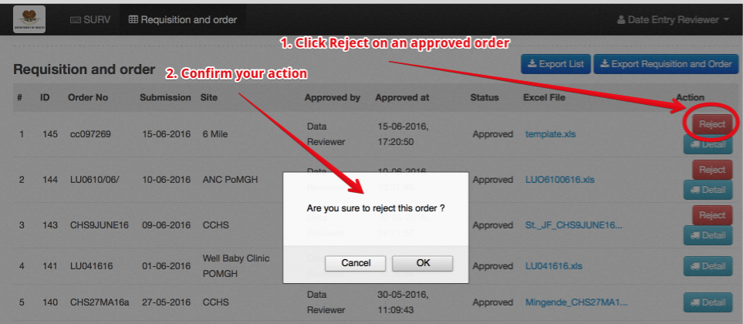

### 3.3.6 Cancel rejection

If you rejected an order by mistake you can put that order back to approved state then AMS can see that order again.

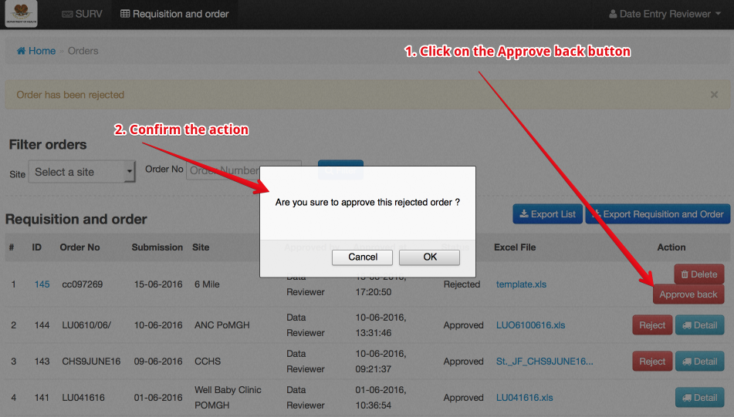

### 3.3.7 Order detail

Click on the “Detail” button

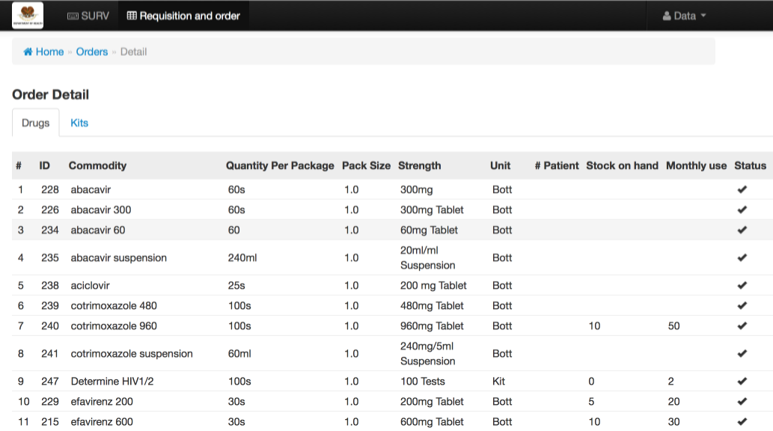

### 3.3.8 Download original order from site

Click on the column Excel File to download the template that was sent from site and then save it.

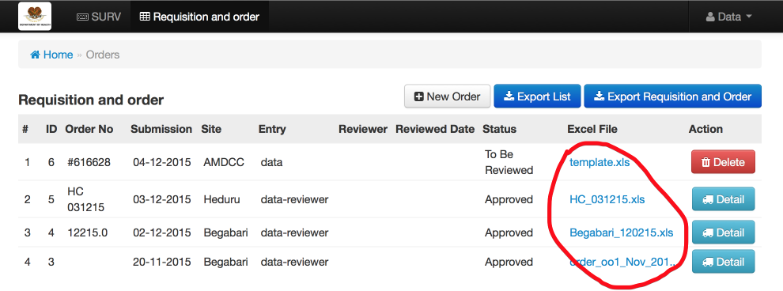

### 3.3.9 Export List

To export the Requisition and order listing, click on the ‘Export List’ blue button and then save the file.

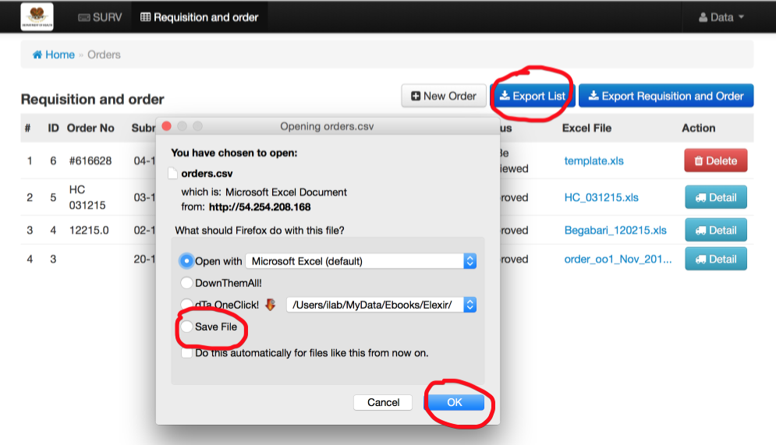

### 3.3.10 Export Requisition and Order

To export requisition and order from all sites within a specific month and year in just one excel file.

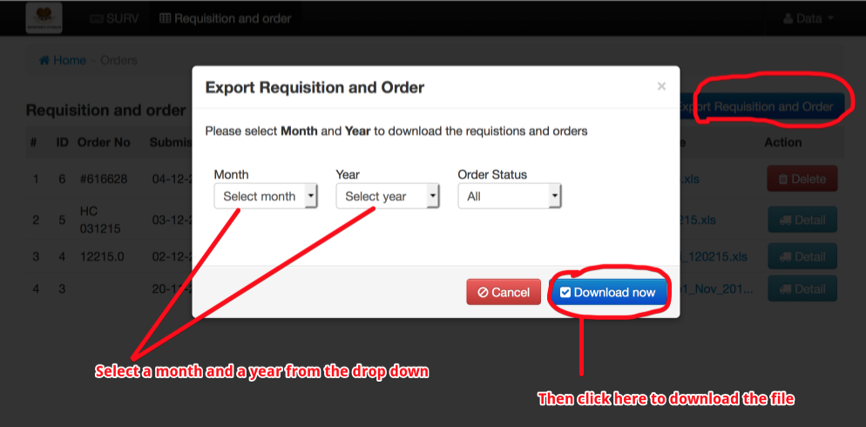

### 3.3.11 Filter orders

If you have big amount of orders, it is hard to find an order. You can quickly search for the order by using the order filter. You can filter by site and order number. If you don’t put anything then all order from all site will be shown.

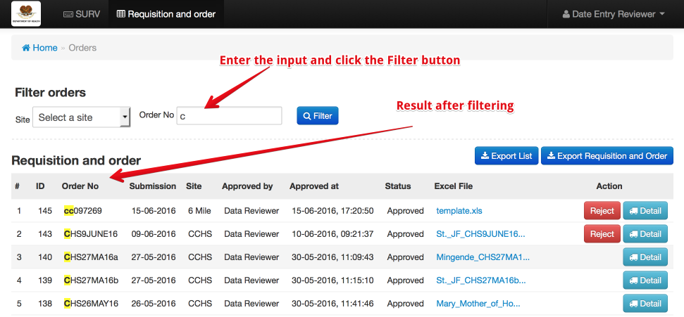

## 3.4 AMS User

### 3.4.1 Dashboard

Show the summary of quantity of orders pending for dispatch (approved order) and quantity of shipments in different states. You can filter the dashboard result by providing the date range ‘From’ and ‘To’ fields.

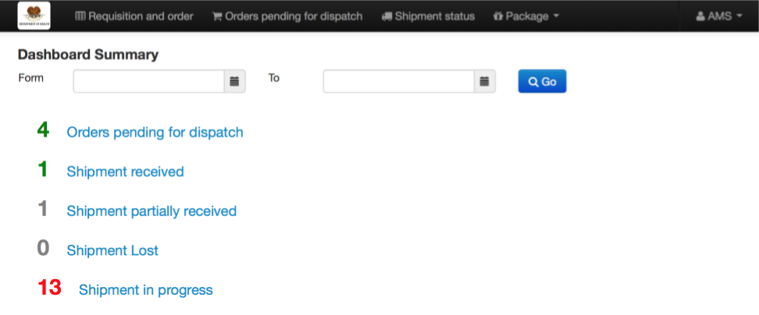

### 3.4.2 Order Listing

On the top menu bar click on ‘Requisition and order.

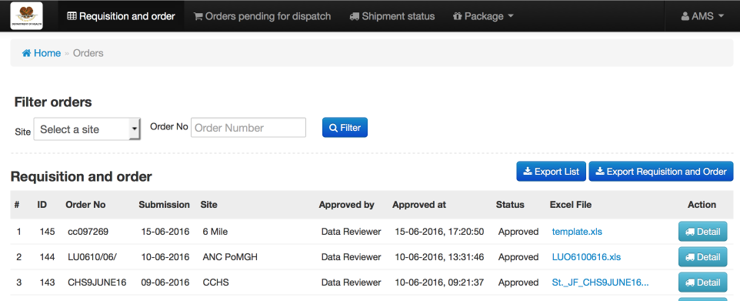

* In ‘Excel File’ column, you can click to download the requisition order excel file submitted by site user.
* The ‘Detail’ button allows you to see the detail of the order approved by reviewer.
* The blue button ‘Export List’ is to export the listing of Requisition and order as CSV format.
* The blue button ‘Export Requisition and Order’ is to export requisitions details from all site within a specific month and year as an excel format

### 3.4.3 Download submitted Requisition and order form

In Excel File column, click one of the values shown in blue color to download requisition form

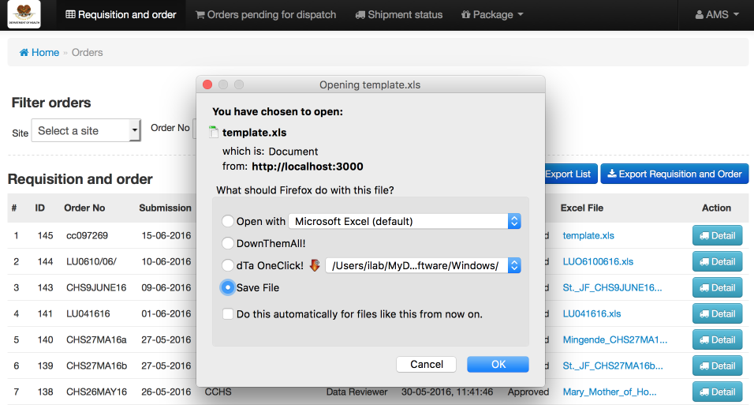

### 3.4.4 Export List

To export Order list in CSV format.

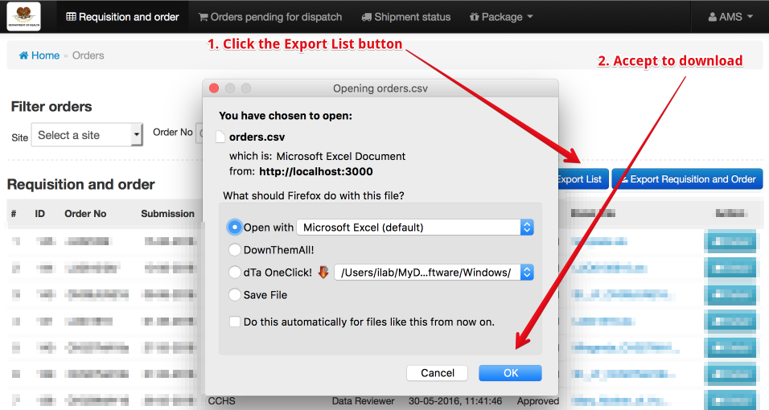

### 3.4.5 Export Requisition and Order

To export requisition and order detail to Excel format.

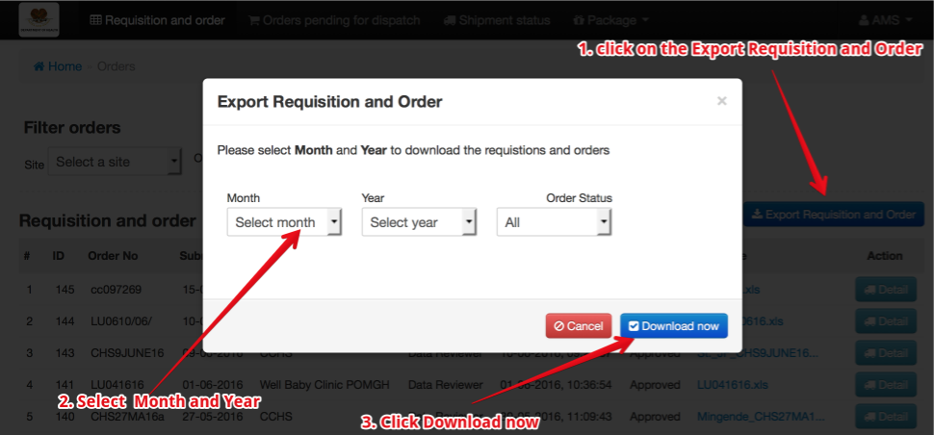

### 3.4.6 Order Filter

To search orders. You can search by site and by order number. If you leave these fields blank then orders from all sites will be returned in the list.

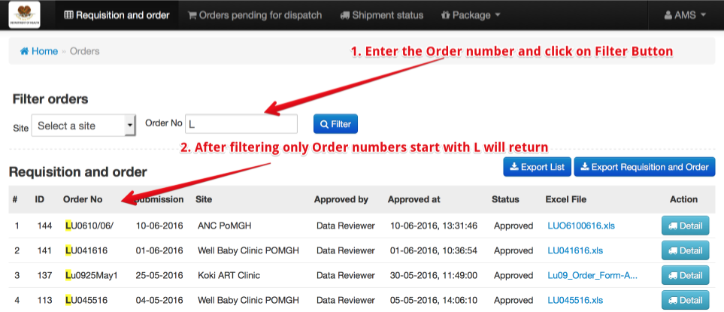

### 3.4.7 Order Detail

In Order listing page click on the Detail button on right part of the table. LOT will show the detail page

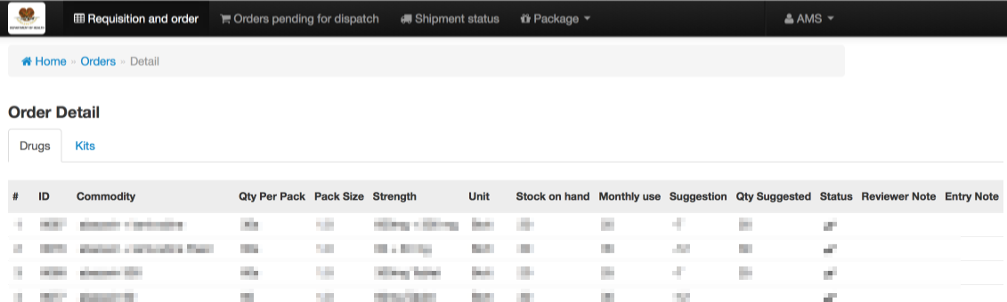

### 3.4.8 Order pending for dispatch

On the top menu bar, click on the ‘Order pending for dispatch’.

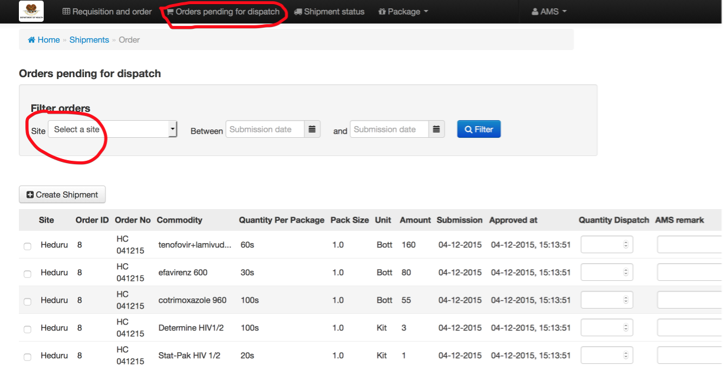

### 3.4.9 Filter Result

You can filter out the items in the list by selecting the ‘Site’ and the between submission and submission and then click Filter.

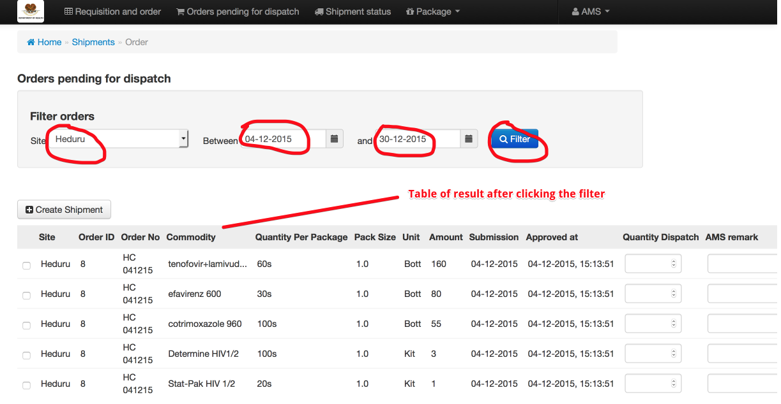

### 3.4.10 Create Shipment

You create shipment by checking on the checkbox of each item and enter the quantity of dispatch and AMS remark (optional), then each row item will turn green to indicate that the item is included in the list to be ship unless you uncheck the checkbox to turn it back off.

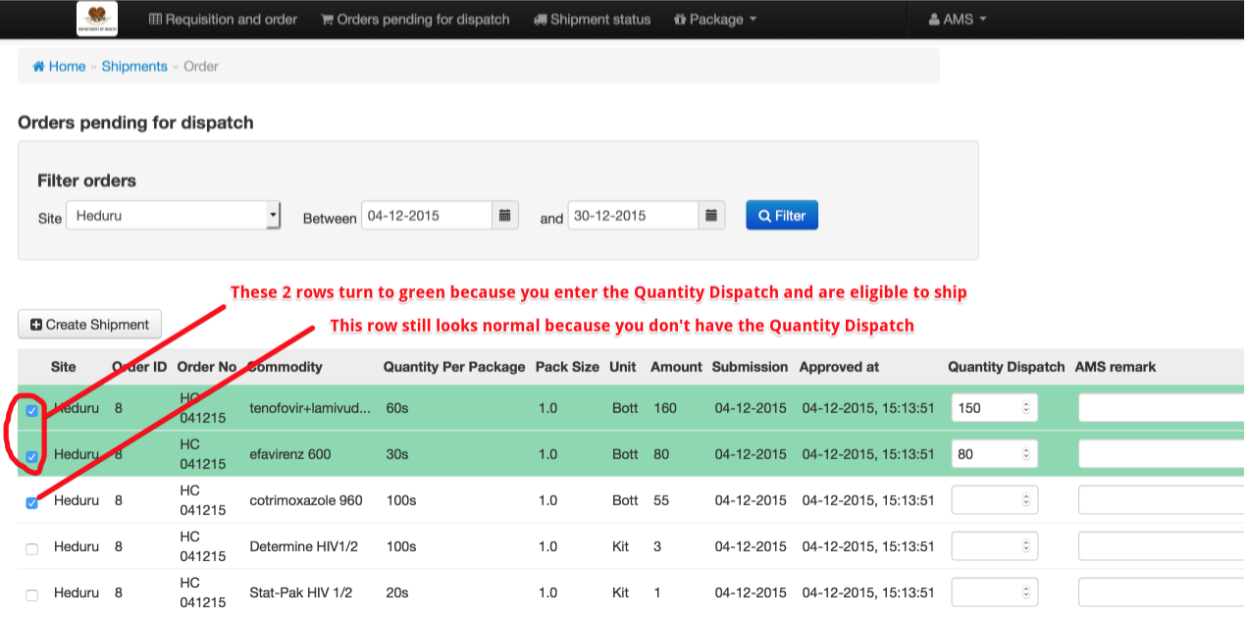

If you don’t filter out by site then your items listing might compose of items from different site. Be careful when selecting the items because you can ship only for items from the same site.

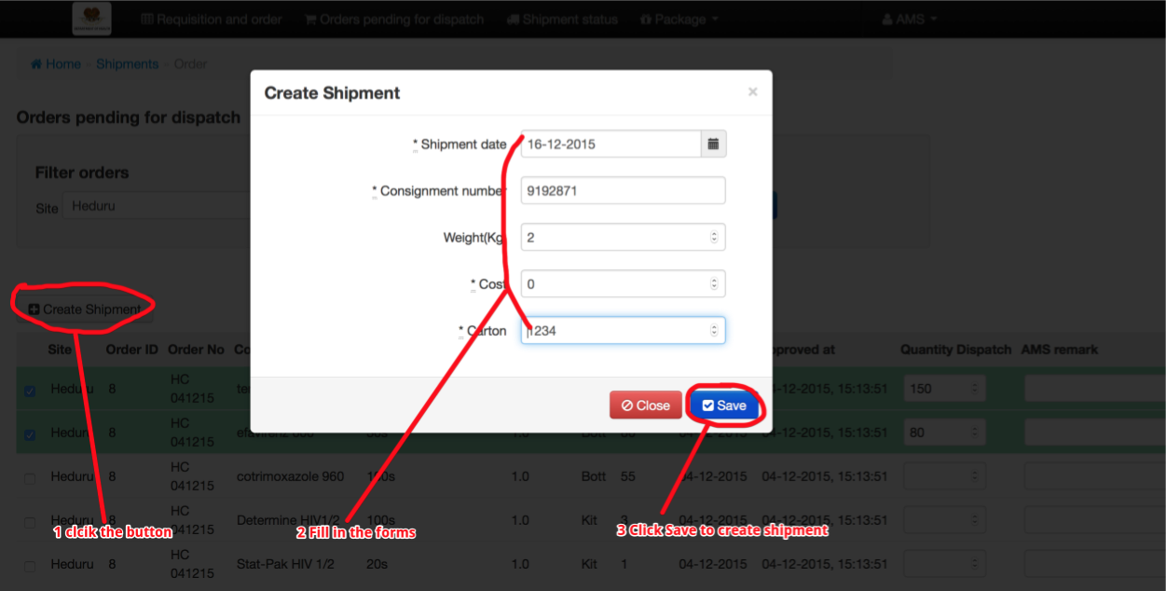

Once you have all the items to ship, click on the ‘Create Shipment’ button then the dialog pops up.

If your form data is not valid it will show the error and you fix it and save it again. If your form is valid, the system will create the shipment, sending an SMS message to Site User about the shipment (SMS message content is dynamic and configurable by Admin User) and system will redirect you to show the shipment status page.

### 3.4.11 Shipment Status

Showing all the shipment with it corresponding status. You can see each shipment detail, SMS message that was sent to Site User and SMS from Site User to update the status of shipment.

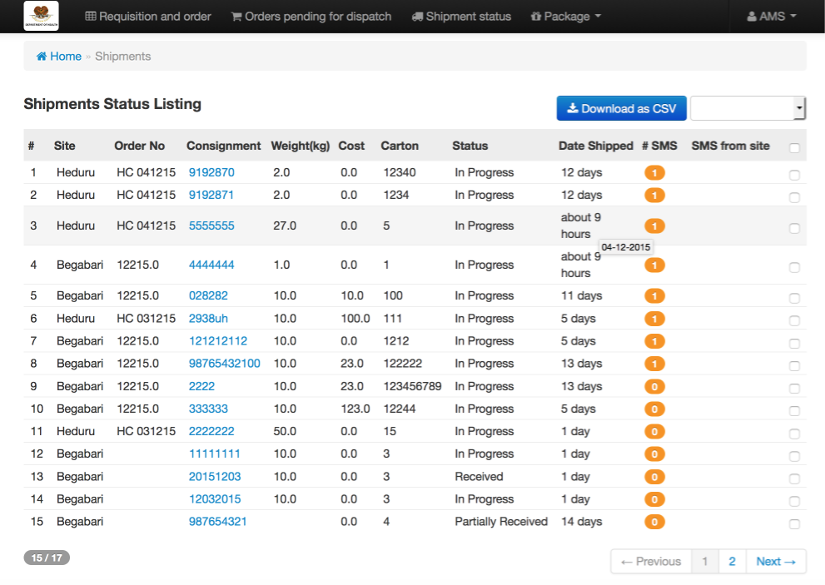

### 3.4.12 Shipment Detail

On shipment status page, click on the consignment number to see the detail of shipment

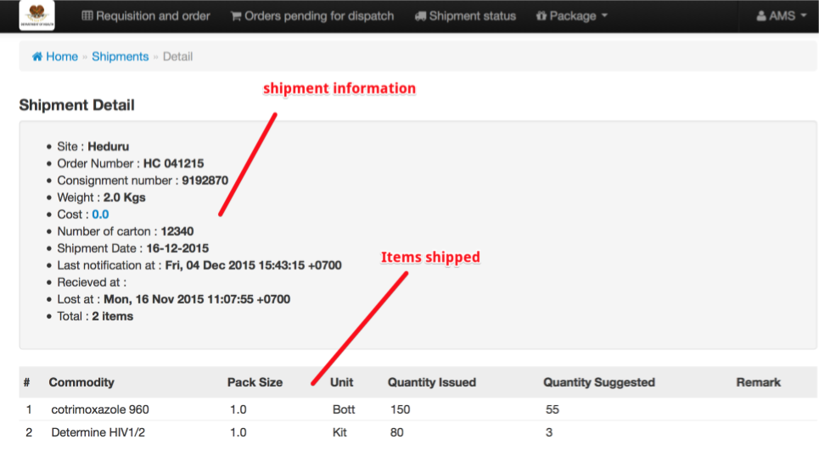

### 3.4.13 Site SMS Messages

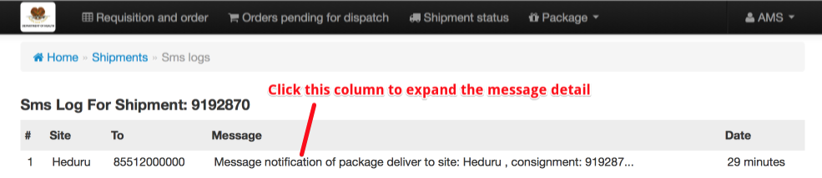

### 3.4.14 Update shipment status

You can update shipment status manually

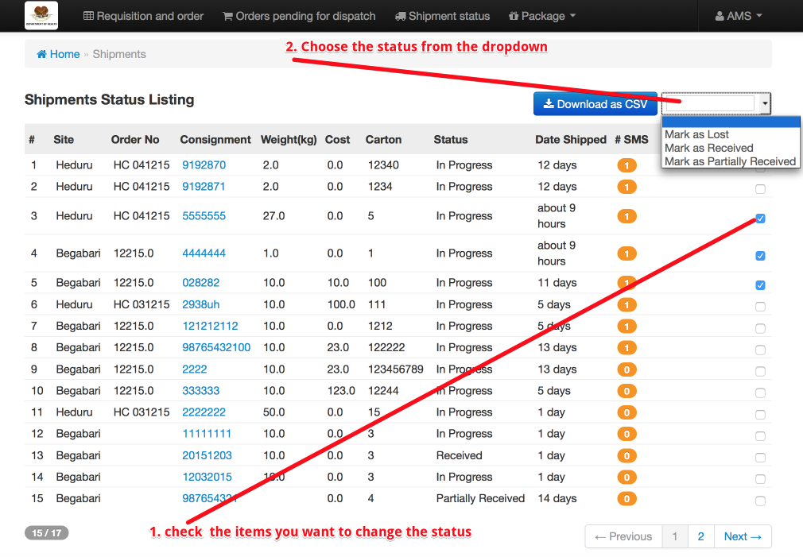

### 3.4.15 Package

Package menu allow you to filter shipments by status. It contains the following status:

1. Shipment in progress
2. Shipment partially received
3. Shipment confirmed
4. Shipment lost

